**EXERCISE: 8**

**DATE: 23.11.2020**

**AIM:**

To write a Python program to get a list of numbers of list and create a list of tuples having first element as the number and second element as the cube of the number.

**PROGRAM:**

n = int(input())

lst = []

for i in range(n):

a = int(input())

lst.append(a)

r = [(j,pow(j,3)) for j in lst]

print(r)

def first(n):

return n[0]

r.sort(key = first)

print(r)

**LINK:**

**http://103.53.53.18/mod/vpl/forms/submissionview.php?id=317&userid=1747**

**OUTPUT:**

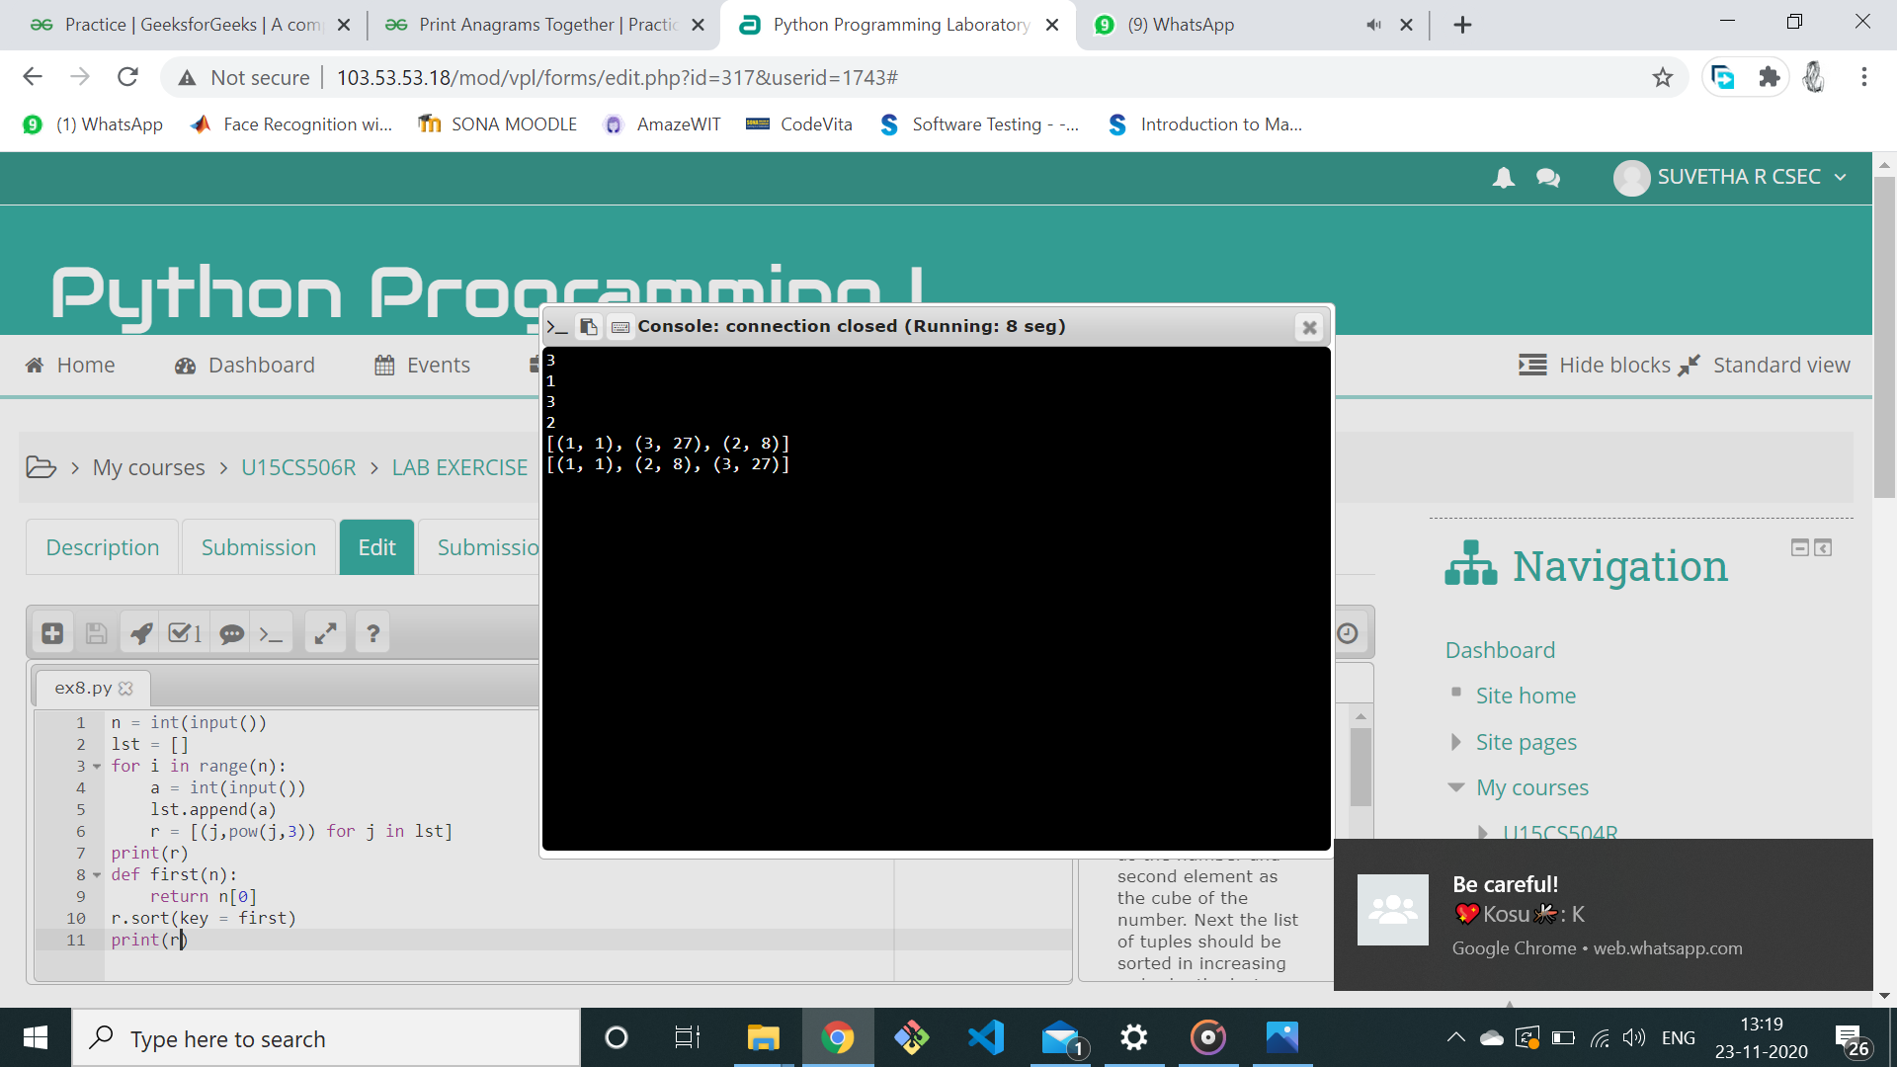

**RESULT:**

The output for the above program is successfully obtained.